Huey P. Newton Reflection

Read the following pages from Huey’s political essays in *The Huey P. Newton Reader*.

129, 134-49

179,

248-255

As you read, highlight or mark quotations that you find interesting, thought provoking, controversial, or inspirational. They may be quotes that you strongly agree with and would incorporate into your personal philosophy. Conversely, they may be quotes you have an adverse reaction to or totally disagree with. They could even be passages that you are confused by or have questions about. You will be writing a reflection on 6 of these quotes. On a separate sheet of paper (in pen or on computer) please write down the quote along with page number in parenthesis. After that write a 4-6 sentence response/reflection describing what you think the quote means, what it was that interested or intrigued you about the quote, and why you think it is important. You may discuss why you agree or disagree with the quotation or what questions you may have about it as well. This is a personal response. Please write a 4-6 sentence reflection for all six quotations. Put your name and correct period at the top of the page!

[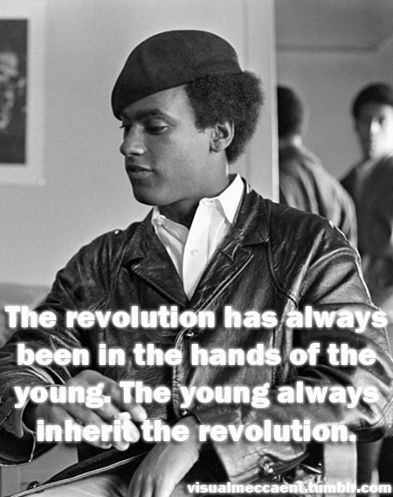](http://www.google.com/url?sa=i&rct=j&q=&esrc=s&frm=1&source=images&cd=&cad=rja&docid=g9Gb51BWGKVRxM&tbnid=6sQiIjc6Cz_14M:&ved=0CAUQjRw&url=http://www.tumblr.com/tagged/huey%20newton&ei=l9tVUdO9DsLtiwKboIG4Bw&bvm=bv.44442042,d.cGE&psig=AFQjCNHjIiqNujS4S6VLzXFDmnN0iZtZmQ&ust=1364667661138967)